**Module 5 Test Review**

(Modeling With Geometry 5.1 – 5.8)

*Use Figure 1 to answer questions 1-6*

|  |  |  |
| --- | --- | --- |
| ______ 1. | sin A |  |
| ______ 2. | cos A |  |
| ______ 3. | tan A |  |
| ______ 4. | sin C |  |
| ______ 5. | cos C |  |
| ______ 6. | tan C | Figure 1 |

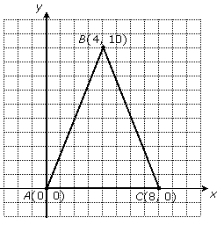

**Part II:** *Short Answer*

7. Find ∠BAC from Figure 2

Figure 2

8. Find ∠ABC from Figure 2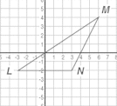

9. Which two line segments are equal in length, but not equal to ?

10. Find the perimeter of ΔLMN. Round your answer to the nearest hundredth.

Figure 3

|  |  |
| --- | --- |
| 11. Label possible side-lengths for the triangle below. | 12. Label possible side-lengths for the triangle below. |

|  |  |
| --- | --- |
| **Law of Sines:** If *ABC* is a triangle with sides *a*, *b*, and *c*, then $$\frac{a}{\sin{A}}=\frac{b}{\sin{B}}= \frac{c}{\sin{C}}$$ or it can be written as: $$\frac{\sin{A}}{a}= \frac{\sin{B}}{b}= \frac{\sin{C}}{c}$$ | **Law of Cosines:** If *ABC* is a triangle with sides *a*, *b*, and *c*, then $$a^{2}= b^{2}+ c^{2}-2bc\cos{A}$$ $$b^{2}= a^{2}+ c^{2}-2ac\cos{B}$$ $$c^{2}= a^{2}+ b^{2}-2ab\cos{C}$$ |
| **Heron’s Area Formula**: If a triangle has sides *a*, *b,* and *c*, then $Area= \sqrt{s(s-a)(s-b)(s-c)}$ where $s=\frac{(a+b+c)}{2}$ | |

**Part III**: *Complete the Triangles*

*Complete the triangles below. Make sure to label your units correctly!*

|  |  |  |
| --- | --- | --- |
| 13. | A =  B =  C =  Area = | a =  b =  c =  Perimeter = |
| 14. | A =  B =  C =  Area = | a =  b =  c =  Perimeter = |
| 15. | A =  B =  C =  Area = | a =  b =  c =  Perimeter = |

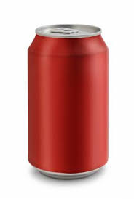**Part III**: *Real World Application*

*A can of soda is 3.6 inches tall and 2.5 inches in diameter. Use this information to answer the questions below.*

16. Draw a two-dimensional shape that would need to be revolved around the x-axis to create the can of soda you see on the right.

|  |
| --- |
|  |

17. Think of a perfect cylinder as the model for the actual soda can. If you took the can apart you would have a lid, a base, and the tin used for the sides. Find the lengths of all of the dotted lines below



18. Using the perfect cylinder model from number 17 above to find how much tin is used to make each soda can. (In other words, what is the surface area of the can?)

19. Using the perfect cylinder model from number 17 above find how much volume would be held in the soda can?

20. When you open a can of soda, you’ll notice that they always leave it a little bit empty. About ¼ inch of the can is air at the top. Find the *actual* volume (in inches3 ) of soda you get when you buy a can.

Identify the method that you would use to find each missing piece.

(Law of sines, Law of Cosines, SOHCAHTOA, Pythagorean Theorem)



|  |  |
| --- | --- |
| 21. Find BC | 22. Find $m∠C$ |
| 23. Find BC | 24. Find $m∠C$ |
| 25. Find BC | 26. Find $m∠C$ |
| 27. Find x | 28. Find $m∠B$ |
| 29. Find a | 30. Find $m∠Q$ |