Module 5 Quiz Review
(Modeling With Geometry 5.1 – 5.4)
Find the measurement for each problem (make sure to put the correct units)
______ 1. | The perimeter of a square that has a side length of 5 cm.
______ 2. | The area of a rectangle that has a length of 4 cm and a height of 5 cm.
______ 3. | The diameter of a circle that has an area of 144π cm²
______ 4. | The volume of a sphere that has a radius of 6 cm
______ 5. | The surface area of a cube (lid included) that has a side length of 3 cm.

6. 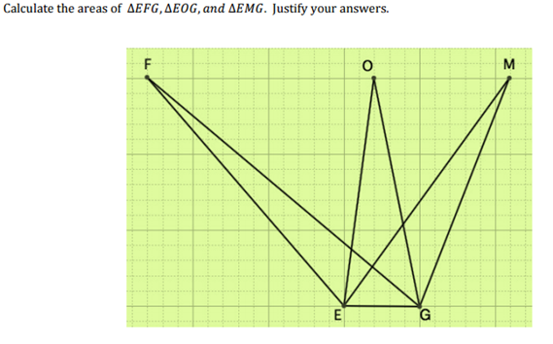
Figure 1

7. Find m∠CAB in Figure 2
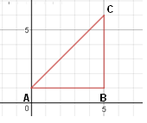
Figure 2

8. Find the measure of m∠C in Figure 3

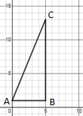
- 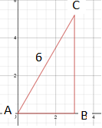
Figure 3

9. What is the perimeter of the triangle in Figure 4?

10. Find $\sin{A}$ in Figure 4
Figure 4

11. If you’ve been watching closely, you’ll notice that $\cos{ C}$ is the SAME as…

12. If the triangle in Figure 4 was revolved around $\overline{BC}$, what shape would be formed?

13. What is the volume of the shape as described in question 12?

Figure 5

Part III: Short Answer
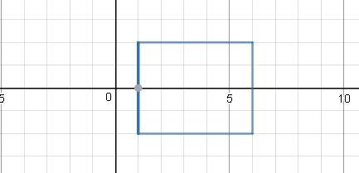
14. If the rectangle was rotated around the x-axis it would create a 3-D shape. Name a common object that has the same shape.

15. If the rectangle was rotated around the y-axis it would create a 3-D shape. Name a common object that has the same shape.

