Semester 1 Final Exam Multiple Choice Review
1. Assume $f(x)$ and $g(x)$ are inverses of one another and drawn on the same graph with the same scale on both the horizontal and vertical axis. What is true of the graph?

2. If ${125}^{2x+5}={125}^{x+3}$, then x= ________

3. Complete the definition of Logarithm: For all positive numbers a, where a ≠ 1, and all positive numbers x, $m=\log_{n}{p}$ means the same as ___________________.

4. Find the inverse of $f\left(x\right)=6^{x}$ ?

5. Name three different ways to write $\sqrt[4]{x^{24}}$ ?
6. a. Draw a graph of $f\left(x\right)and g\left(x\right)where f and g are inverses of each other.$

b. Draw a graph of $f\left(x\right)and g\left(x\right)where f and g are not inverses of each other.$
Simplify (on 10 and 11 use definition of log)
7. | $$a^{x}∙a$$
8. | $$\frac{b^{x}}{b}$$
9. | $$\sqrt{c^{2x}}$$
10. | $$d^{x}=3$$
11. | $$e^{2}=f$$

12. If $\log_{a}{b}=c$ , is it possible for c to equal a negative number? Explain.

13. Simplify ${\left(7b^{-5}\right)}^{2}$?

14. Expand $\log_{2}{{\left(\frac{2}{xy}\right)}^{3}}$

15. Write equivalent statements to the following argument. $\log_{7}{x}-\log_{7}{3}=0$.

16. We know that $f\left(x\right)$ and $g\left(x\right)$ are inverses of one another. What can you conclude about this inverse relationship?

17. If $\left(x\right)=\log_{x}{243}$ , then $f\left(3\right)=$

18. Find a point on the graph of $y=\log_{7}{x}$ ?

Simplify

19. | $$\log_{25}{625}$$
20. | $$\log_{421}{421}$$
21. | $$\log_{x}\left(x^{62}\right)$$
22. | $$\log_{9}{\frac{1}{9}}$$
23. | $$\log_{7}{1}$$

Make a table for each of the following
24. | Linear | a. | x y  1 2 3 4 5 2 6 18 54 162
25. | Exponential | b. | x y  1 2 3 4 5 -1 4 11 20 31
26. | Quadratic | c. | x y  1 2 3 4 5 3 5 7 9 11
27. | Cubic | d. | x y  3 6 9 12 18 1 2 3 4 5
28. | Logarithmic | e. | x y  1 2 3 4 5 1 7 21 49 97

29. Label the above functions as whether they or NOT also be considered a polynomial function.

30. If $\left(x\right)=x^{3}+27$, then what is $f(-4)$?

31. Factor $x^{3}+125$,

32. Write the function in standard form that has roots 2 and -3

33. Determine which of the following are even
a. $x^{3}-3x$
b. $x^{2}-4$
c. ${\left(x-4\right)}^{2}$
d. $x^{4}+5$
e. ${\left(x+5\right)}^{4}$

34. Decide whether x=-3 is a solution to the following function
$\frac{4}{(x-3)(x+4)(x-1)}=0$

Match each rational function on the left with its graph on the right. Asymptotes are shown as dotted lines in the graphs.
35. $f\left(x\right)= \frac{1}{x^{2}+8x+15}$
36. $f\left(x\right)=\frac{x^{2}-9}{x}$ | 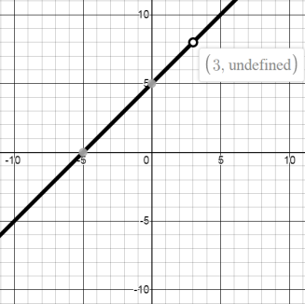
37. $f\left(x\right)=\frac{x+5}{x-3}$ | 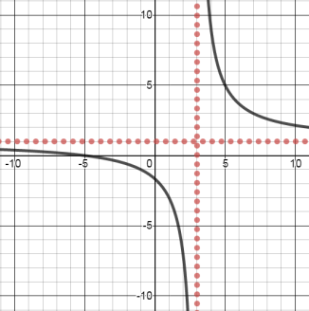
38. $f\left(x\right)=\frac{x^{2}+2x-15}{x-3}$ | 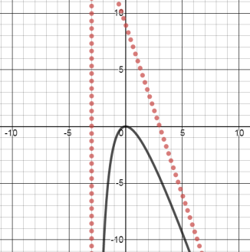
39. $f\left(x\right)=\frac{-3x^{2}}{x+3}$ | 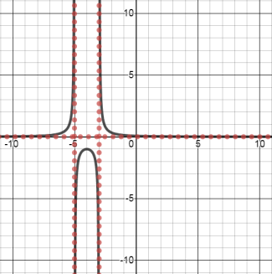

40. One of the graphs from above is an odd function. Which one?

41. Solve and identify any extraneous solutions. $\frac{x^{2}-3x-10}{x-5}=0$

42. Which of the following are proper rational functions
a. $\frac{x+3}{x-4}$
b. $\frac{1}{x^{2}-3x+4}$
c. $\frac{x^{2}+4x-5}{x^{2}+5x-3}$
d. $\frac{x^{2}-4x+3}{x^{3}-8}$
e. $\frac{\left(x+2\right)\left(x-3\right)}{{\left(x-5\right)}^{2}\left(x+1\right)}$
h. $\frac{x^{2}+5}{x-4}$

